PROFILE

(MOHD HALIM BIN HARON)

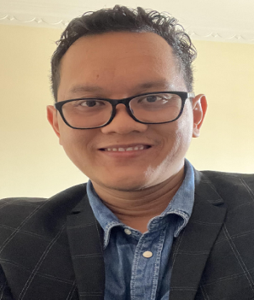

MOHD HALIM BIN HARON graduated from Cyberjaya University College Of Medical Science (CUCMS) with Bachelor (Hons) in Occupational Safety & Health. He is also an HRD Corp Accredited Trainer since 2022. Alumni of Saito University College as a graduated student in Dip. Security Management. Registered Safety & Health Officer and a Competent SHASSIC Assessor.

He is married with 2 kids and resides in Petaling Jaya, Selangor. He was awarded as a Best Student Award during a convocation ceremony for his remarkable achievement in security management.

Mohd Halim has been a OSH Practitioner for more than 9 Years. He has served in various industries in some sector ie; Oil & Gas, Services, Manufacturing and Construction. He has held all levels of position in the Health, Safety & Environment, including heading the HSE department as an Acting HSE Manager in one of greatest company in heavy engineering and building construction for Tun Razak Exchange (TRX) project.

Throughout his involvement in the Health, Safety & Environment fields, his forte has been in Occupational Safety & Health Management, Risk Management, Incident Reporting & Investigation, Legal Requirements, ISO45001 Audit, Safety & Health Assessment System In Construction (SHASSIC) & Behavioral Based Safety. He has gained experiences and contributing excellent OSH management skills and led process process improvement in HSE in numerous projects.

Mohd Halim has an interest in OSH Management within in organization context and development of safe work practices and cultures in various working industry. He also believes the value of effective performance of OSH management system in driving results within the organization. He has been involved in internal and public training in these areas to help organization achieve their OSH Objectives & Targets.

